

**DOCTOR MANAGEMENT SYSTEM**

STEP 1:

User Story:

1. As a user I want to add my clinic and chamber description and also my medical working field in my website.
2. As a user I want to add my clinic or chamber working day in my website so that I can manage my patients online.
3. As a user I want to edit my information so that I can change any kind of wrong information in my description.
4. As a user I want to have virtual doctor appointment system so that my patients can ask for appointment in my website.
5. As a user I want to have email confirmation system so that I can confirm their appointment through email
6. As a user I want to delete all my data in case I change my location or go abroad.

STEP 2:

User Case:

Add:

|  |  |  |
| --- | --- | --- |
| Requirements | Key Feature | Criteria |
| As a user I want to add my clinic and also my chamber description. | To make a user friendly, Data should be saved without refreshing page. (Ajax) | 1.    Only user can add description without any problem.(Core features)  2.    User should see the success/failure message. (Message)  3. input field need to use with correct format with Validation)  4.    No empty value is accepted.(Empty Validation)  5.    Input should be Sanitized to secure the application  (Sanitization)  6.   In case of invalid input JavaScript message should be displayed. (Usability/User Friendly |

Edit:

|  |  |  |
| --- | --- | --- |
| Requirements | Key Feature | Criteria |
| As a user I want to edit my chamber information so that I can correct any mistakes. | To make a user friendly, Data should be saved without refreshing page. (Ajax) | 1.   User can edit information without any problem.(Core features)  2.    User should see the success/failure message. (Message)  3. Information input format must be used for validate the field. (Format Validation)  4.     No empty value is accepted.(Empty Validation)  5.     Input should be Sanitized to secure the application  (Sanitization)  6.     In case of invalid input JavaScript message should be displayed. (Usability/User Friendly Interface) |

View:

|  |  |  |
| --- | --- | --- |
| Requirements | Key Feature | Criteria |
| As a user I want to show my chamber information so that I can communicate with my patient’s |  | User can view information without any problem.(Core features) |

View Patients list:

|  |  |  |
| --- | --- | --- |
| Requirements | Key Feature | Criteria |
| As a user I want to see my patients appointment request in a list for specific date so that I can communicate with my patient’s |  | List must have certain limit for any specific date. |
| As a user I want to download my patients appointment requests as PDF format |  |  |
| As a user I want to send confirmation email to my patients so that I can call them for visit. |  |  |

Delete:

|  |  |  |
| --- | --- | --- |
| Requirements | Key Feature | Criteria |
| As a user I want to delete my clinic and also my chamber description in case I go abroad. | To make a user friendly, Data should be deleted without refreshing page. (Ajax) | 1.Only user can delete description without any problem.(Core features)  6.   In case of invalid action JavaScript message should be displayed. (Usability/User Friendly |

**Step 3:**

**Robustness Diagram**

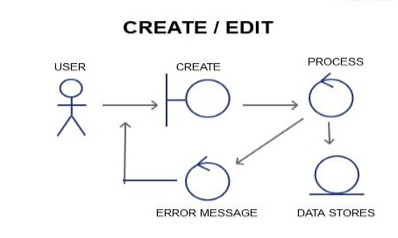

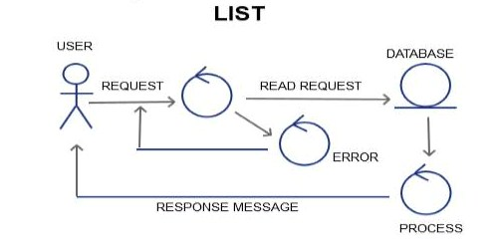

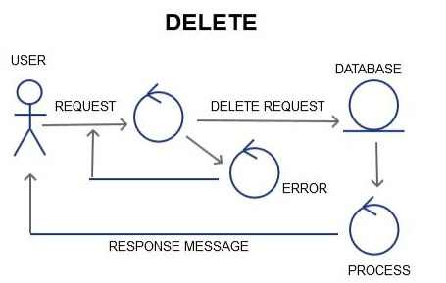

#### Sequence Diagram:

#### Create/add /edit

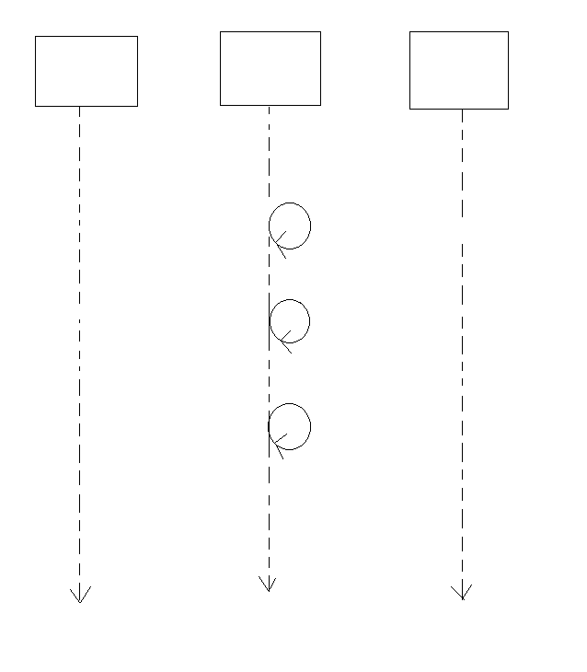

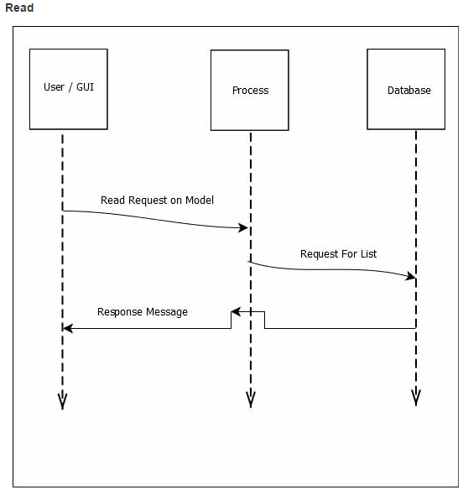

**Delete:**

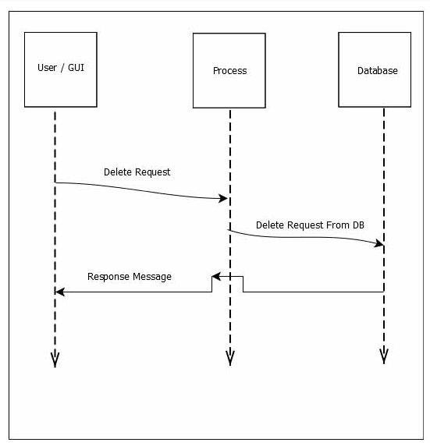

**Database Relationship:**

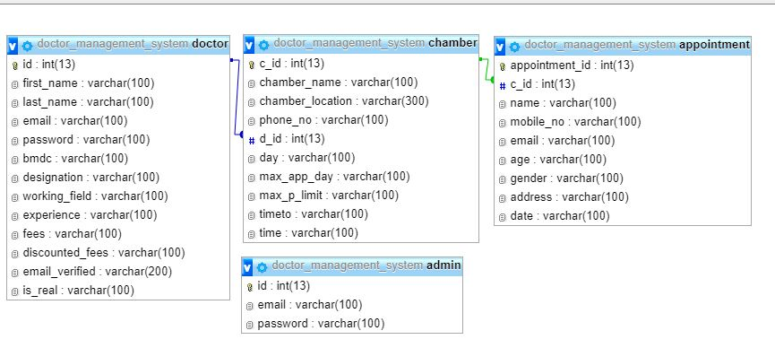

**Class:**

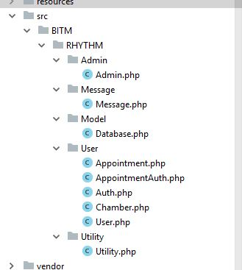

**MOCKUP:**

**Doctor Create:**

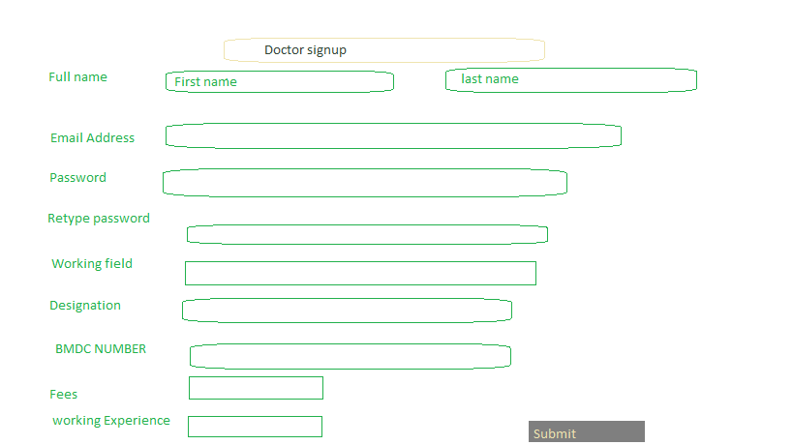

**Doctor Edit:**

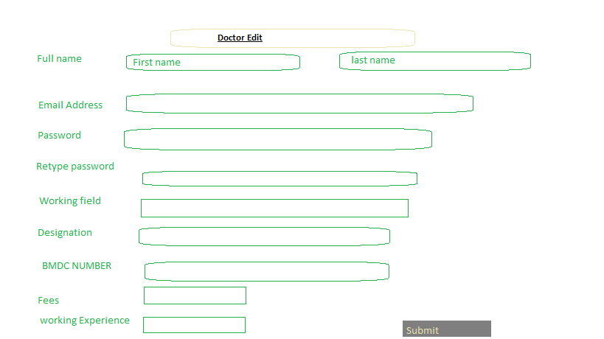

**Create Chamber:**

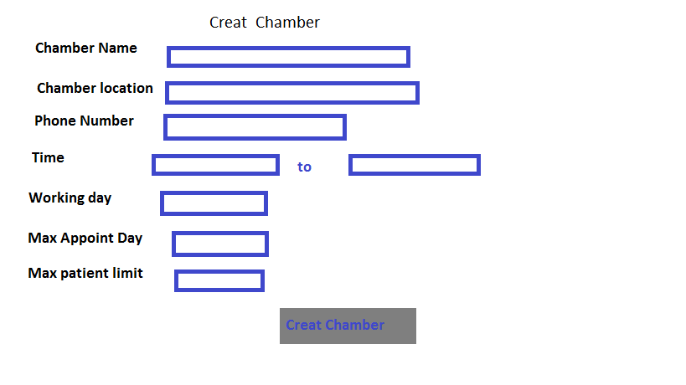

**Edit chamber:**

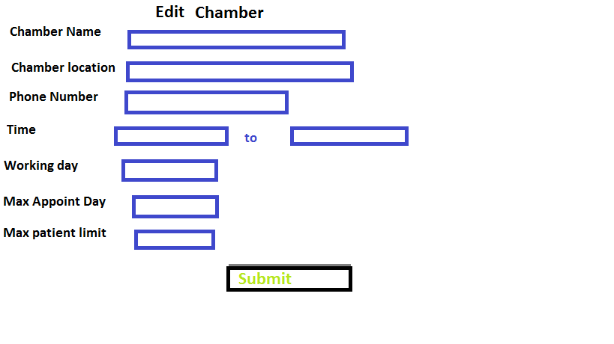

**Take appointment:**

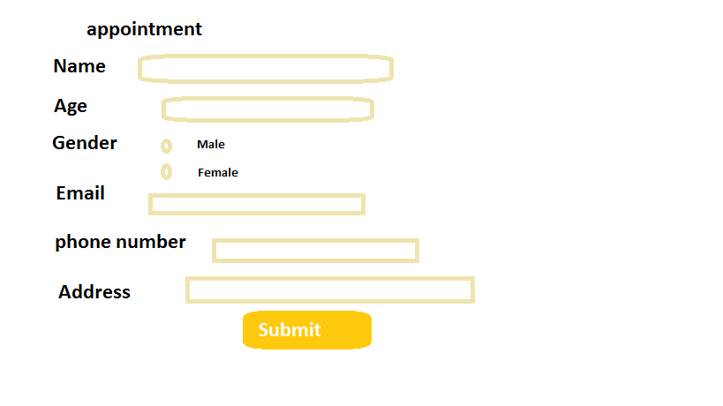

**Admin Login:**

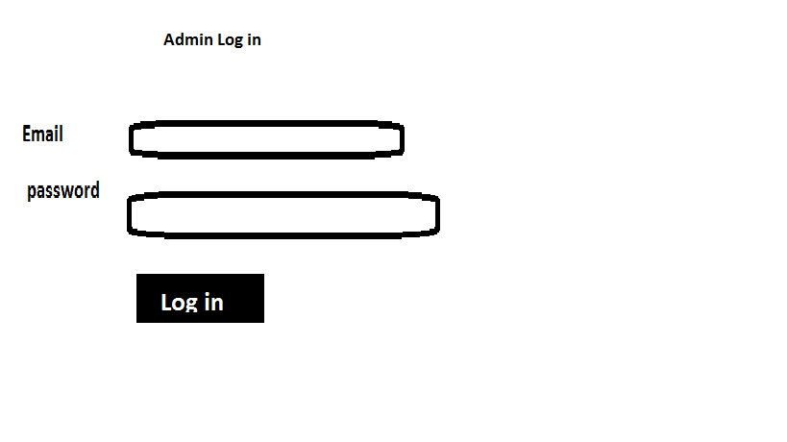

**Create Admin:**

